|  |  |
| --- | --- |
| **Soal Praktikum**  *Practicum Case* |  |
| ISYS6028  Database Systems |
| **Teknik Informatika**  *Computer Science* | CS- ISYS6028-Var01 |
| **Periode Berlaku Mulai** Semester Ganjil 2017/2018  ***Valid on*** *Odd Semester Year* 2017/2018 | **Revisi 00**  *Revision 00* |

**Learning Outcomes**

* Apply database language and SQL Programming language

## Topic

* Session 03 **-** SQL – Data Manipulation (1)

## Sub Topics

* **Insert Data**
* **Delete Data**
* **Update Data**
* **Begin Trans**
* Simple Query

**Tabel Relasional**

*Relational Table*

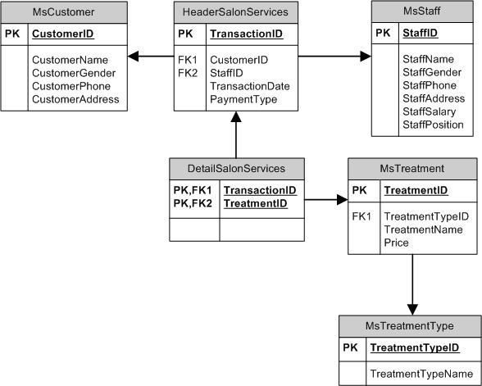

**Sintaks**

*Syntax*

[**Insert Into**](http://www.1keydata.com/sql/sqlinsert.html)  
INSERT INTO table_name [ ( field1_name , field2_name [, ...] ) ]  
VALUES ( value1 , value2 [, ...] )

[**Update**](http://www.1keydata.com/sql/sqlupdate.html)  
UPDATE table1_name  
SET field1_name = new_value [, …]  
[ FROM table1_name, table2_name [, …] ]  
WHERE condition

[**Delete From**](http://www.1keydata.com/sql/sqldelete.html)  
DELETE FROM table_name [, …]  
WHERE condition

## Soal

*Case*

1. Insert the following data.

(**insert**)

**Table : MsStaff**

|  |  |  |  |  |  |  |
| --- | --- | --- | --- | --- | --- | --- |
| StaffId | StaffName | StaffGender | StaffPhone | StaffAddress | StaffSalary | StaffPosition |
| SF006 | Jeklin Harefa | Female | 085265433322 | Kebon Jeruk Street no 140 | 3000000 | Stylist |
| SF007 | Lavinia | Female | 085755500011 | Kebon Jeruk Street no 153 | 3000000 | Stylist |
| SF008 | Stephen Adrianto | Male | 085564223311 | Mandala Street no 14 | 3000000 | Stylist |
| SF009 | Rico Wijaya | Male | 085710252525 | Keluarga Street no 78 | 3000000 | Stylist |

**Table : HeaderSalonServices**

|  |  |  |  |  |
| --- | --- | --- | --- | --- |
| TransactionId | CustomerId | StaffId | TransactionDate | PaymentType |
| TR010 | CU001 | SF004 | 2012/12/23 | Credit |
| TR011 | CU002 | SF006 | 2012/12/24 | Credit |
| TR012 | CU003 | SF007 | 2012/12/24 | Cash |
| TR013 | CU004 | SF005 | 2012/12/25 | Debit |
| TR014 | CU005 | SF007 | 2012/12/25 | Debit |
| TR015 | CU005 | SF005 | 2012/12/26 | Credit |
| TR016 | CU002 | SF001 | 2012/12/26 | Cash |
| TR017 | CU003 | SF002 | 2012/12/26 | Credit |
| TR018 | CU005 | SF001 | 2012/12/27 | Debit |

**Table : DetailSalonServices**

|  |  |
| --- | --- |
| TransactionId | TreatmentId |
| TR010 | TM003 |
| TR010 | TM005 |
| TR010 | TM010 |
| TR011 | TM015 |
| TR011 | TM025 |
| TR012 | TM009 |
| TR013 | TM003 |
| TR013 | TM006 |
| TR013 | TM015 |
| TR014 | TM016 |
| TR015 | TM016 |
| TR015 | TM006 |
| TR016 | TM015 |
| TR016 | TM003 |
| TR016 | TM005 |
| TR017 | TM003 |
| TR018 | TM006 |
| TR018 | TM005 |
| TR018 | TM007 |

2. Insert the following data.

(**insert, dateadd, day, getdate**)

**Table : HeaderSalonServices**

|  |  |  |  |  |
| --- | --- | --- | --- | --- |
| TransactionId | CustomerId | StaffId | TransactionDate | PaymentType |
| TR019 | CU005 | SF004 | Obtained by adding 3 days to current date. | Credit |

3. Insert the following data.

(**insert, round, rand**)

|  |  |  |  |  |  |  |
| --- | --- | --- | --- | --- | --- | --- |
| StaffId | StaffName | StaffGender | StaffPhone | StaffAddress | StaffSalary | StaffPosition |
| SF010 | Effendy Lesmana | Male | 085218587878 | Tanggerang City Street no 88 | Obtained from random number between 3000000 and 5000000 | Stylist |

1. Change CustomerPhone by replacing ‘08’ with ‘628’ on **MsCustomer** table. Then display all data on **MsStaff** table.

**(update, replace)**

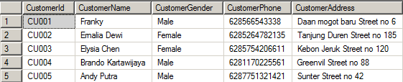

1. Change the StaffPosition into ‘Top Stylist ‘and add StaffSalary by 7000000 on **MsStaff** table for every staff whose name is ‘Effendy Lesmana’. Then display all data on **MsStaff** table.

**(update, like)**

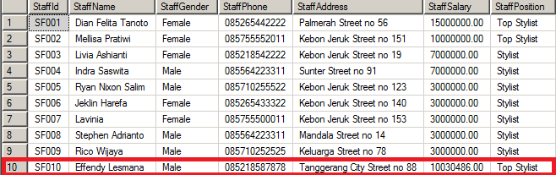

1. Change the CustomerName into the first name of CustomerName (obtained from the first character of CustomerName until character before space) on **MsCustomer**  table for every customer who did transaction on 24th day. Then display all data on **MsCustomer** table.

**(update, left, charindex, datepart, day)**

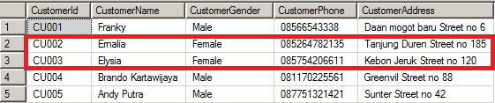

1. Change CustomerName by adding ‘Ms. ’ in front of it on **MsCustomer** table for every customer whose id is ‘CU002’ or ’ CU003’. Then display all data on **MsCustomer** table.

**(update, in)**

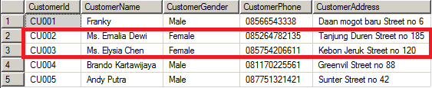

1. Change CustomerAddress into ‘Daan Mogot Baru Street No. 23’ on MsCustomer table for every customer that has been served by staff whose name is ‘Indra Saswita’ and the transaction occurred on Thursday. Then display all data on **MsCustomer** table.

**(update, in, exists, datename, weekday)**

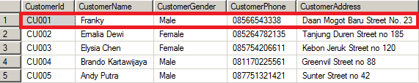

1. Delete data on **HeaderSalonServices** table for every transaction which is done by the customer whose name doesn’t contains space. Then display all data on **HeaderSalonServices** table.

**(delete, join, charindex)**

**Before** deleted:

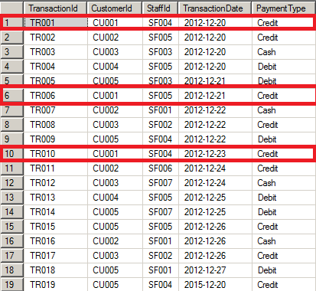

**After** deleted:

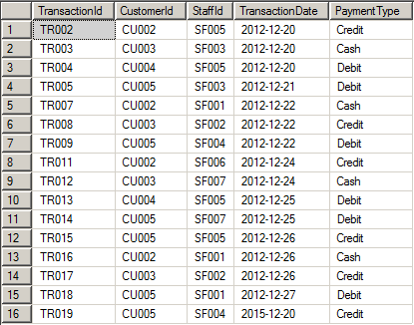

1. Delete data on **MsTreatment** table for every treatment which type doesn’t contains ‘treatment’ word. Then display all data on **MsTreatment** table.

**(delete, in, not like)**

**Before** deleted:

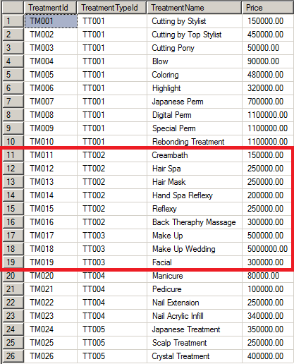

**After** deleted:

